Q2. USING TERRAFORM CREATEAN AWS EKS CLUSTER CREATE FOLLOWING COMPONENTS  
 I.VPC-2 PUBLIC SHEET AND 2 PRIVATE SUBNETS.  
 II.IAM ROLE – FOR MASTER AND WORKER.  
 III.WORKER NODE FOR CLUSTER USING AMAZON LINUX.

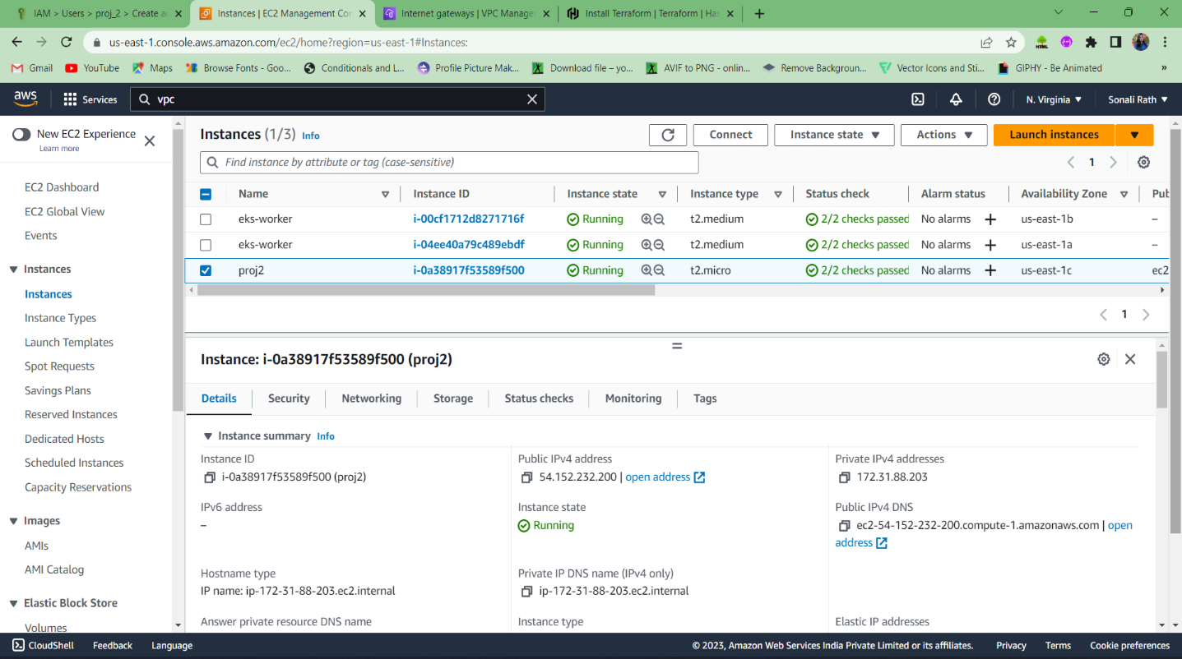

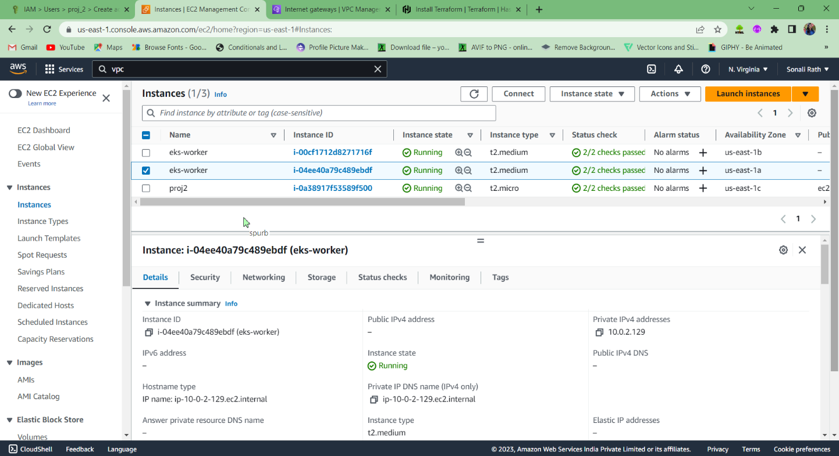

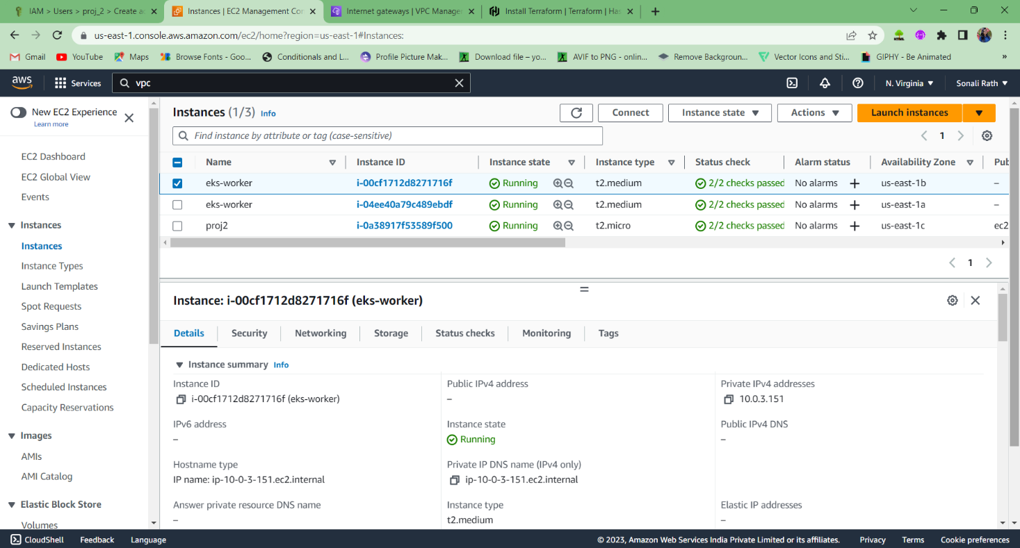

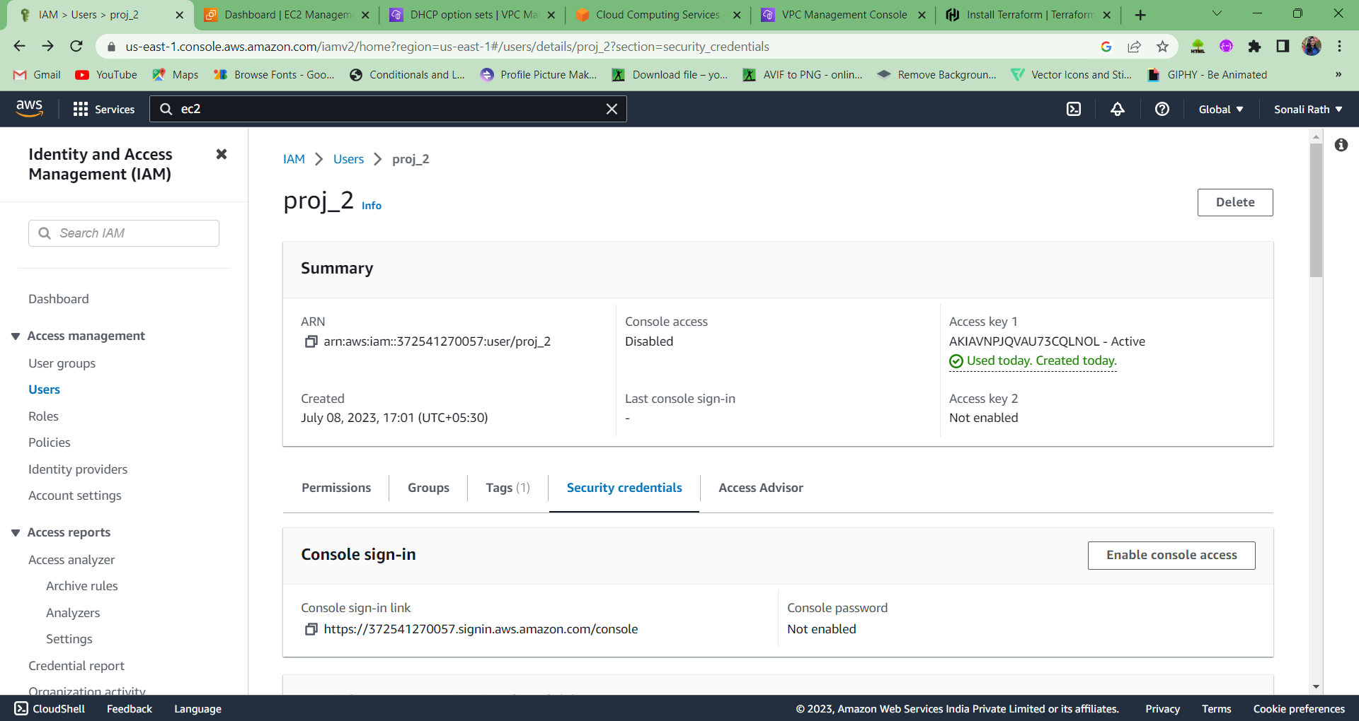

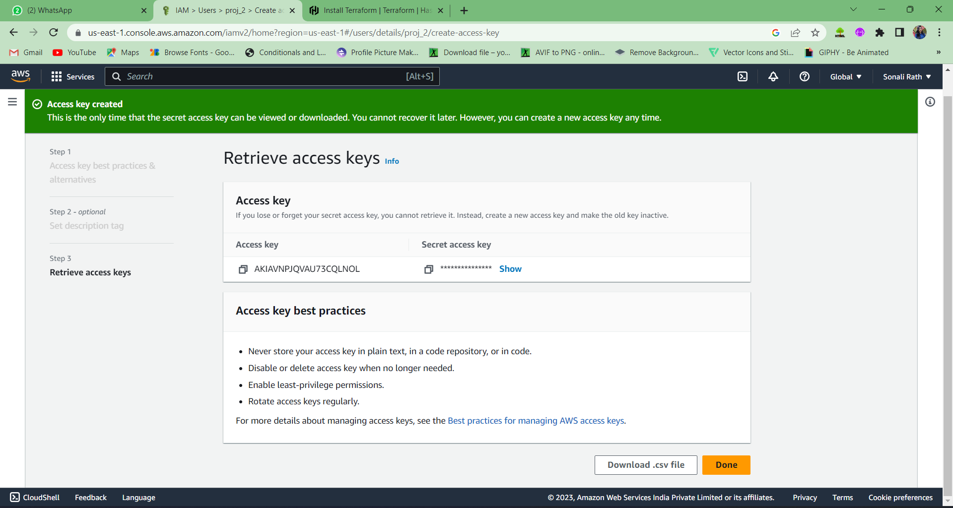

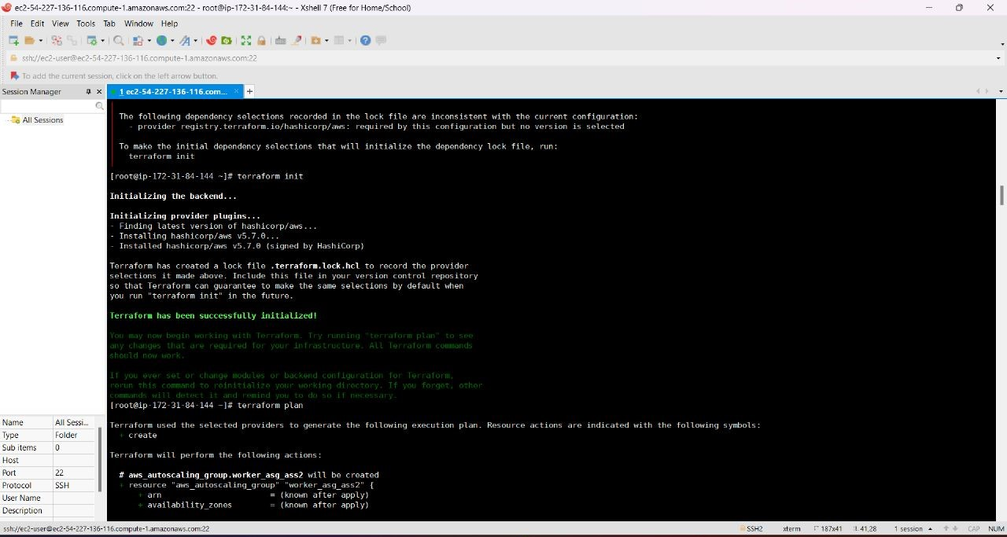

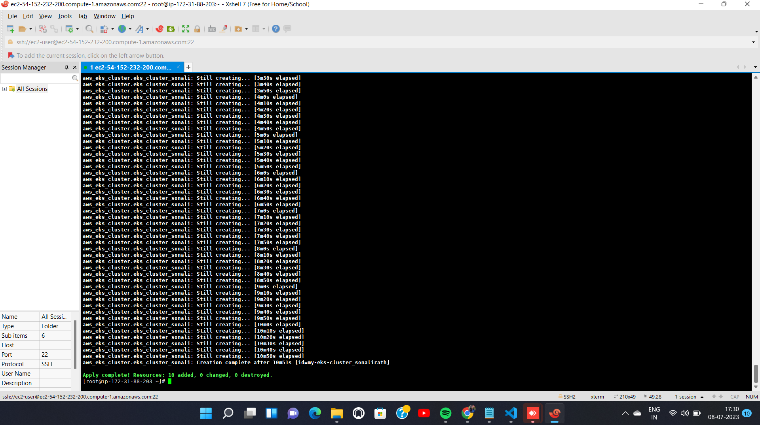

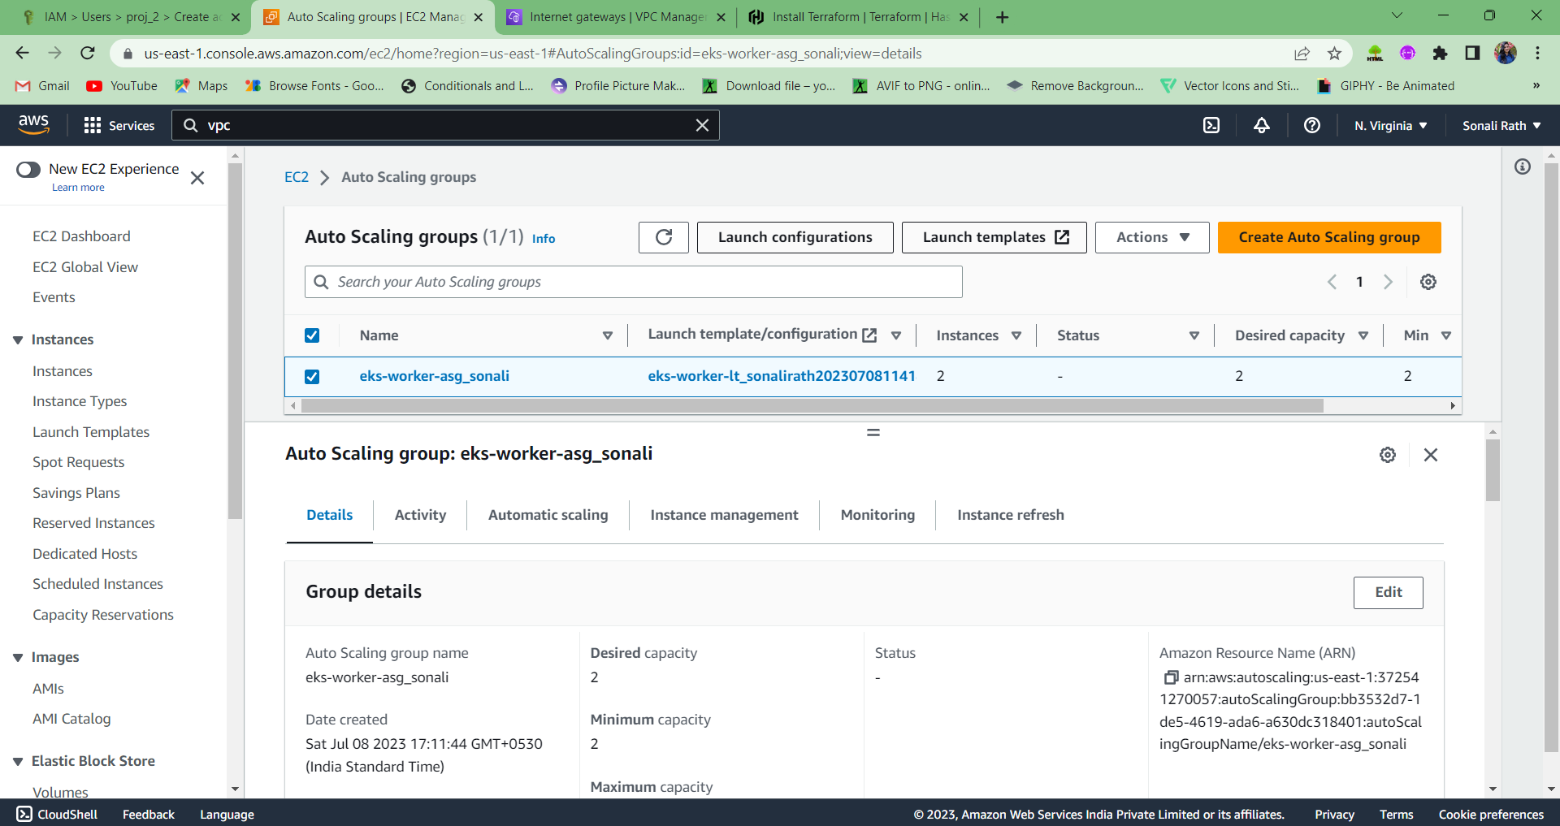

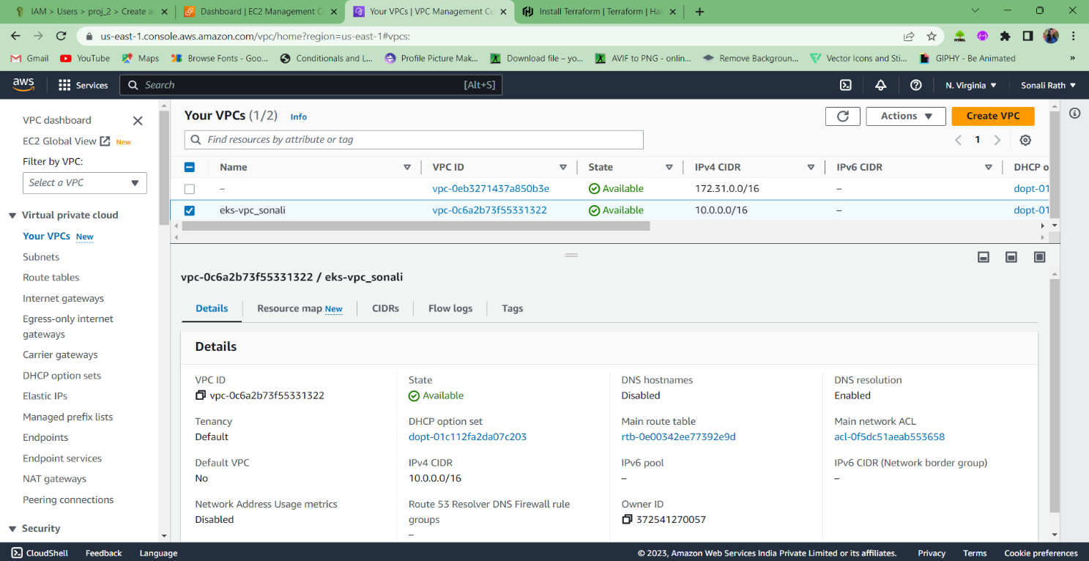

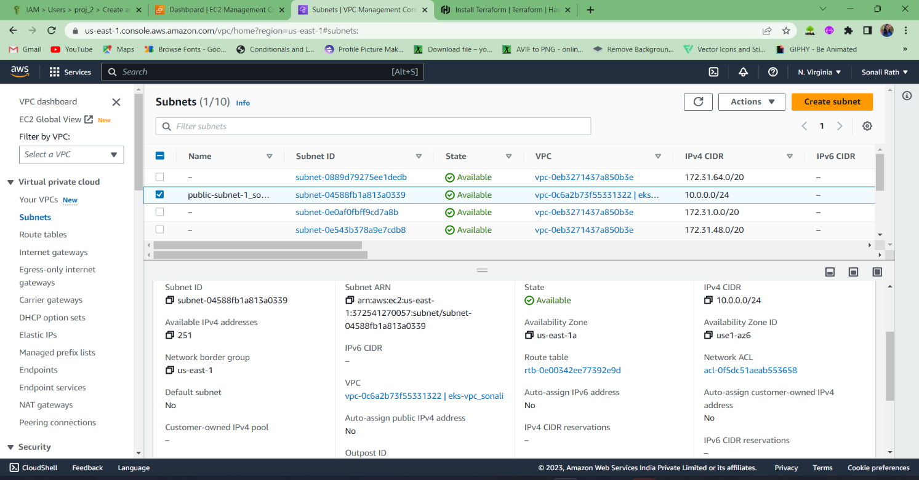

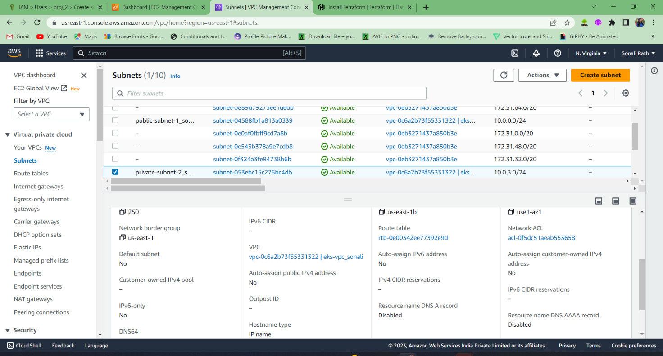

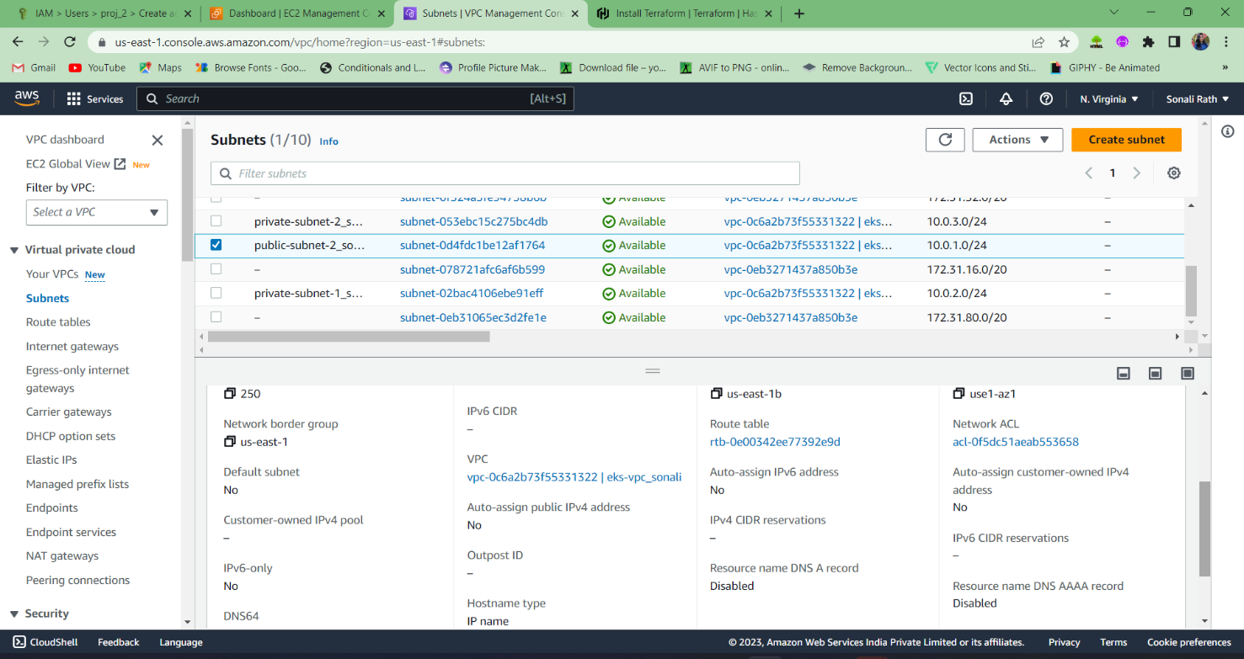

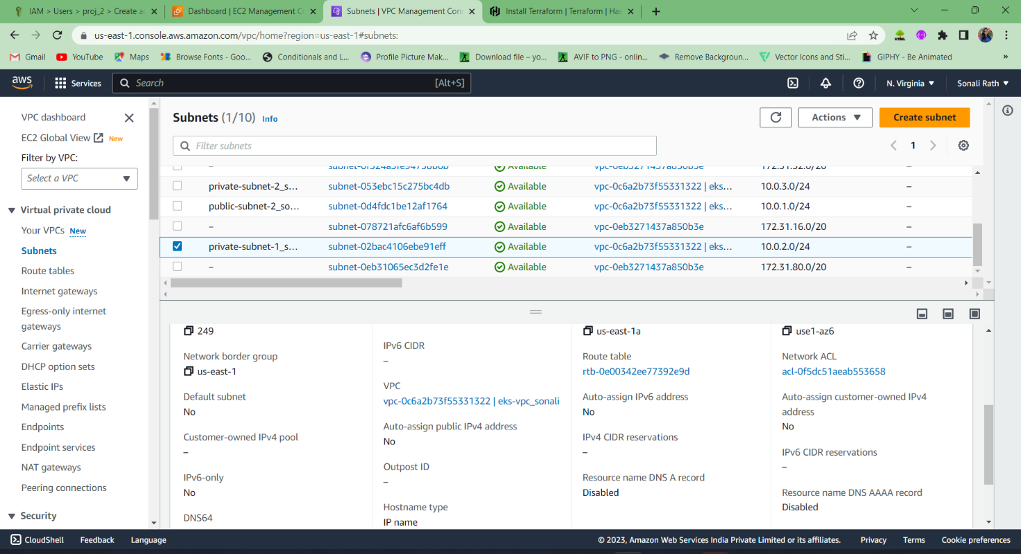

**Main.tf(terraform file)**

# Define the provider

provider "aws" {

region = "us-east-1" # Replace with your desired region

}

# Create VPC for the EKS cluster

resource "aws_vpc" "rath_eks_vpc_sonali" {

cidr_block = "10.0.0.0/16" # Replace with your desired CIDR block

tags = {

Name = "eks-vpc_sonali"

}

}

# Create public subnets for the EKS cluster

resource "aws_subnet" "rath_public_subnet_1_sonali" {

vpc_id = aws_vpc.rath_eks_vpc_sonali.id

cidr_block = "10.0.0.0/24" # Replace with your desired CIDR block

availability_zone = "us-east-1a" # Replace with your desired availability zone

tags = {

Name = "public-subnet-1_sonalirath"

}

}

resource "aws_subnet" "rath_public_subnet_2_sonali" {

vpc_id = aws_vpc.rath_eks_vpc_sonali.id

cidr_block = "10.0.1.0/24" # Replace with your desired CIDR block

availability_zone = "us-east-1b" # Replace with your desired availability zone

tags = {

Name = "public-subnet-2_sonalirath"

}

}

# Create private subnets for the EKS cluster

resource "aws_subnet" "rath_private_subnet_1_sonali" {

vpc_id = aws_vpc.rath_eks_vpc_sonali.id

cidr_block = "10.0.2.0/24" # Replace with your desired CIDR block

availability_zone = "us-east-1a" # Replace with your desired availability zone

tags = {

Name = "private-subnet-1_sonalirath"

}

}

resource "aws_subnet" "rath_private_subnet_2_sonali" {

vpc_id = aws_vpc.rath_eks_vpc_sonali.id

cidr_block = "10.0.3.0/24" # Replace with your desired CIDR block

availability_zone = "us-east-1b" # Replace with your desired availability zone

tags = {

Name = "private-subnet-2_sonalirath"

}

}

# Create IAM roles for the EKS cluster

resource "aws_iam_role" "rathsonali_eks_worker_role" {

name = "eks-worker-role_sonalirath"

assume_role_policy = jsonencode({

Version = "2012-10-17"

Statement = [

{

Action = "sts:AssumeRole"

Effect = "Allow"

Principal = {

Service = "ec2.amazonaws.com"

}

}

]

})

managed_policy_arns = [

"arn:aws:iam::aws:policy/AmazonEKSClusterPolicy"

]

}

resource "aws_iam_role" "rathsonali_eks_master_role" {

name = "eks-master-role_sonalirath"

assume_role_policy = jsonencode({

Version = "2012-10-17"

Statement = [

{

Action = "sts:AssumeRole"

Effect = "Allow"

Principal = {

Service = "eks.amazonaws.com"

}

}

]

})

managed_policy_arns = [

"arn:aws:iam::aws:policy/AmazonEKSClusterPolicy"

]

}

# Create the EKS cluster

resource "aws_eks_cluster" "eks_cluster_sonali" {

name = "my-eks-cluster_sonalirath"

role_arn = aws_iam_role.rathsonali_eks_master_role.arn

version = "1.27" # Replace with a supported Kubernetes version

vpc_config {

subnet_ids = [

aws_subnet.rath_public_subnet_1_sonali.id,

aws_subnet.rath_public_subnet_2_sonali.id,

aws_subnet.rath_private_subnet_1_sonali.id,

aws_subnet.rath_private_subnet_2_sonali.id,

]

}

}

# Create the launch template for worker nodes

resource "aws_launch_template" "worker_lt_sonali" {

name_prefix = "eks-worker-lt_sonalirath"

image_id = "ami-04823729c75214919" # Replace with the desired Amazon Linux AMI ID

instance_type = "t2.medium" # Replace with your desired instance type

block_device_mappings {

device_name = "/dev/xvda"

ebs {

volume_size = 8 # Replace with your desired root volume size in GB

}

}

}

# Create the autoscaling group for worker nodes

resource "aws_autoscaling_group" "worker_asg_sonali" {

name = "eks-worker-asg_sonali"

launch_template {

id = aws_launch_template.worker_lt_sonali.id

version = "$Latest"

}

min_size = 2 # Replace with your desired minimum number of worker nodes

max_size = 5 # Replace with your desired maximum number of worker nodes

desired_capacity = 2 # Replace with your desired initial number of worker nodes

vpc_zone_identifier = [

aws_subnet.rath_private_subnet_1_sonali.id,

aws_subnet.rath_private_subnet_2_sonali.id,

]

tag {

key = "Name"

value = "eks-worker"

propagate_at_launch = true

}

**NAME: SONALI RATH**

**SIC NUMBER : 20BCEE70**